AUSTRALIAN COUNCIL FOR THE DEFENCE OF GOVERNMENT SCHOOLS

PRESS RELEASE 514#

CHOICE OF PUBLIC SECONDARY EDUCATION

UNDER THREAT IN AUSTRALIA

14 May 2013

Many parents wishing to enrol their children in public schools throughout Australia are confronted with a choice between Buckleys and None. Australian conservative governments no longer accept responsibility for the entitlement of EVERY Australian child to a public secondary education.

In Victoria there will be six new Catholic secondary schools ( at least) built while Christian and Muslim schools are expanding. New secondary schools in the Naphthine/Dixon budget are like hen’s teeth.
Any new public secondary schools have come as the result of community struggles and those fighting for them are to be congratulated. In Canberra, new unnecessary, sectarian schools are cannibalising existing public secondary schools.

In their battle of basic educational opportunities for their children, Australian parents need to come to terms with two basic education policies held by current governments.

Both of these polices are very old but are being re-cycled in the 21st century with a vengeance by Mr Abbott, his sectarian mates in the Coalition,and his mates in the Institute of Public Affairs.

- The first policy is that the church or churches control the education of children but at taxpayer expense. i.e. as in the middle ages and up to the Enlightenment of the late C18, the denominational system should take priority over any public system. Education for the poor is a charity, not a right.
Religious men, particularly those promoting entanglement of religion with the State have NEVER accepted a role for the State in Education beyond generous endowments.
Nor have they ever accepted that education should be free, secular and universal, providing educational opportunities for all children. Muslim educational institutions cannot even conceive of a State separate from Religion. This is the basis of a theocracy, not a democracy.

- The second policy is related to the ‘free market’ – survival of the fittest – user pays - ideology. Although this Thatcherite ideology has gained primacy since the 1980s, it is grounded in the centuries before the Enlightenment and the nineteenth century British Reform Acts.
It is the basis of an aristocratic or plutocratic form of government – not a democracy.

The basis of a strong public education system is consequently under direct attack but parents are out and about, demanding public secondary schools for their children.

Parents have to fight hard for any new public secondary school. Consider the following examples:

The Doreen Secondary School: Success at Last.

After considerable lobbying over a period of years, parents of public school children in the outer suburb of Doreen have finally obtained the funding for a new secondary college. All power to them. But it will almost certainly be a public/private partnership.

http://www.premier.vic.gov.au/media-centre/media-releases/6684-new-secondary-college-for-doreen.html

But What about the Mernda P-12 College?

But the following glossy Developers’Notice which stands in front of an empty paddock some kilometres away at Mernda is symbolic.

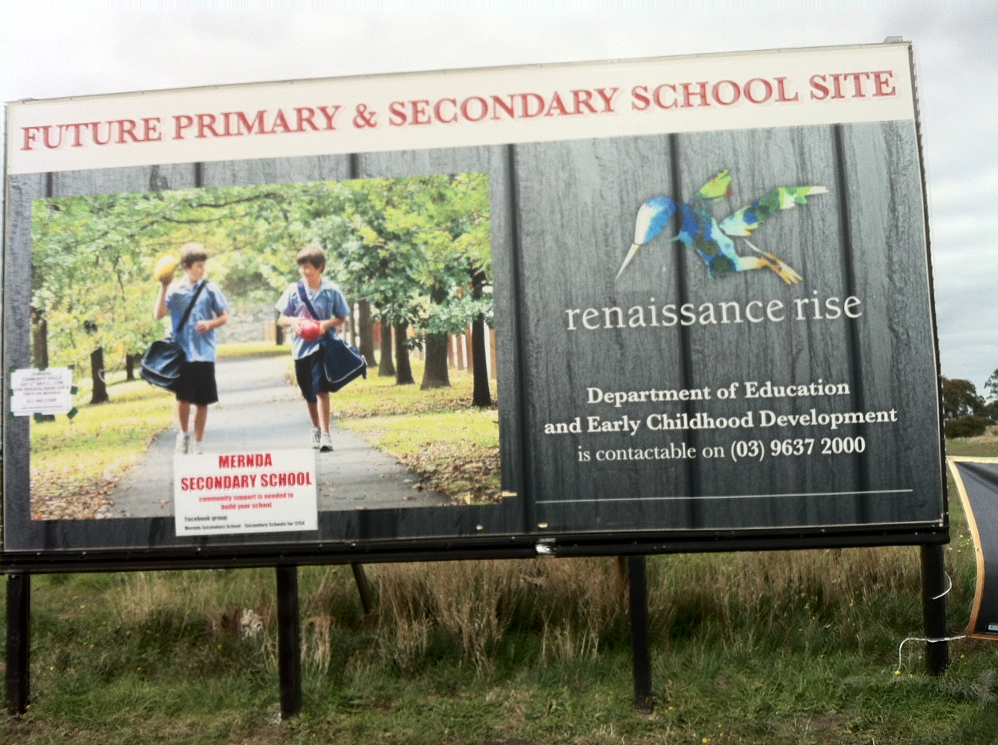

Notices appended to it announce that public school parents are demanding the choice of a local, public secondary school for their children. And on 11 December 2012 a Doreen-Mernda alliance formed to lobby politicians.
http://whittlesea-leader.whereilive.com.au/news/story/alliance-formed-to-lobby-pollies
/Cheryl Balfour article
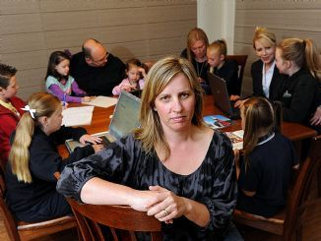
Doreen and Mernda Secondary School Alliance spokeswoman Lisa Muldoon. Picture: KYLIE ELSE
They have vowed to lobby the government and opposition until a college is delivered. The group wants a commitment from the major political parties to fund the construction of a secondary college in the 2013 budget. They want to enrol their children at the new college by 2016.
"Based on the 2011 census results for Doreen, Mernda and Yarrambat, there will be 1816 children of secondary school age by the year 2015," Ms Muldoon said.
"Considering the Department of Education and Early Childhood and Development quote that a minimum of 1100 students are required for a secondary school to be viable, then the statistics speak for themselves."
For more information, search for Doreen and Mernda Secondary School Alliance on Facebook.
The 2013-14 Budget is down and the efforts of the Mernda parents so far have been in vain. A new primary schools in the Epping area will be a Catholic primary school to which a state government developer, ‘Places Victoria’is contributing $650,000. And a new Catholic school is projected to soon join the Anglican, Christian, and Seventh Day Adventist secondary school in the area.
http://www.theage.com.au/victoria/schools-cash-goes-west-as-demands-on-budget-head-north-20130429-2ioze.html
Keep Battling Mernda parents – you need to do so in the brave new age of educational disentitlement.
Coburg High School

Meanwhile Coburg High School parents have battled to provide a senior campus for their college and had some success at least to the point of promises – promises. See Posts from High School for Coburg for 05/10/2013‏ High School for Coburg (highschoolforcoburg@gmail.com) However, the expansion and refurbishment of Coburg Senior High School does not appear to be in 2013-14 State Government budget. The DEECD assured HSC last year that the timeline would still be workable if funding for Capital Works wasn’t in the budget until 2014-15 as all planning and design work could be done without specific budget allocation. Minister Dixon announced in a July 18 Press Release the decision to expand Coburg Senior High (CSHS) in 2015. "This is an excellent outcome for the Coburg community," Mr Dixon said

.But the Coburg parents are still in ‘consultation’ without any hard cash.

But What About another Primary School for North Melbourne ?
and

What About a Public as opposed to a Private School for the Docklands?
Whereas public schools were built in developing areas before private schools, it is now the other way around. As the denominational system gains momentum in this country, this sectarian system is cannibalising areas where public schools already exist.

Cannibalisation of Public Schools in Canberra
On 8 May 2013, Emma Macdonald, the Education Editor for the Canberra Times reported the outcry in Canberra as the ACT government approved three new private schools schools - two Christian and one Islamic - to be built in the ACT despite vehement protests from public education groups that they threaten the viability of government schools and could ''cannibalise'' enrolments.
See http://www.canberratimes.com.au/act-news/outcry-as-private-schools-approved-20130507-2j67p.html#ixzz2SkWjTF2n

Brindabella Christian College has been allowed to establish a campus at the old Charnwood High School, while the Seventh Day Adventist-run Canberra Christian College will build a school in the new Molonglo suburb of Wright, and the At Taqwa Islamic School has been approved for Gungahlin.
A spokesman for Ms Burch, the Education Minister for the ACT said the approvals could be found on the Education Directorate website and did not warrant a press release.
The union's ACT branch secretary Glenn Fowler condemned government ''secrecy'' surrounding the decision saying there had been high community interest in the outcome.
''The fact that vast sums of public money will be used to subsidise these private creations means that the public must be informed of the ACT government's decisions,'' he said.
Save Our Schools campaigner Trevor Cobbold said the the decision would draw enrolments from existing schools in Belconnen, add to excess capacity and threaten the future of some schools.
''The minister's approval of a new school in Belconnen defies all logic. It contradicts the government's own long-term policy to reduce excess school capacity in the region,'' he said. Both believed it was insulting to the public to approve a private school in Belconnen after the distressing closure of Flynn Primary School in 2006.
''Cannibalisation is the only possible outcome,'' Mr Fowler said. ''This represents a significant shift in priorities and members of the public should have a genuine say as to whether this is the way they want the ACT to go.''
Mr Cobbold said the new Brindabella Christian School campus in Charnwood would be within a few hundred metres of Charnwood-Dunlop Primary and St Thomas Aquinas Primary schools. Flynn Primary - just over a kilometre away - was closed despite public outcry because the government said there was over-capacity in the region.
Mr Cobbold said there was no case for another private school in Belconnen given there were nearly 2000
excess places in government schools in north-west Belconnen and projected population growth in Belconnen to 2021 was estimated at only 0.3 per cent a year, compared with the ACT average of 1.4 per cent.
For a full report from the Save Our Schools group see http://www.saveourschools.com.au/media-releases/education-minister-should-be-sacked-for-turning-the-approval-process-for-new-private-schools-into-a-shambles

THE DOGS RADIO PROGRAM
3CR
855 ON THE AM DIAL
12.00 NOON SATURDAYS

