KARMEL TO GONSKI: THE QUEST FOR EQUALITY IN AUSTRALIAN EDUCATION

In this paper I wish to explore a central question:
- Why has the ideal of ‘equality’in Australian education as articulated by Karmel in 1973 and Gonski in 2011 persisted, despite its obvious cleavage with reality?

- This question assumes a number of others. For example, what has been the reality, as opposed to the rhetoric of educational equality.?

- The subject is fraught with political and emotional overlays and I hope the paper will excite discussion. Funding statistics are often contestable. But enrolment statistics are not - and they tell their own story.

- Karmel, the economist, had an explanation for the failure to reduce inequalities. He blamed, among other things, a ‘paradigm shift’ in economic policy in the 1980s. Eminent political economists agree with him.
So I suggest two reasons for the persistence of the ideal:
- The ideal is perennial and surfaces many times in history, particularly in times of crises.
- Inequalities in educational provision are a reflection on inequalities in the society itself. Since 2000 there has been a global upsurge in data gathering and the study of inequality by political economists who agree with Karmel’s economic analysis. I wish to refer to some of the work in this parallel academic world, and place persistence of the ideal –yet failure of implementation in this context.
- In conclusion, I wish to refer to three reasons given by Thomas Picketty, the French economist for the failure of social democratic regimes like Australia to prevent the upsurge in inequality since 1980.

KARMEL AND GONSKI: The Ideal
On 12 December 1972, the Interim Committee for the Australian Schools Commission was appointed by the Hon. E.G. Whitlam, Prime Minister of Australia.
The Committee was asked to ‘make recommendations as to the immediate financial needs of schools, priorities within those needs, and appropriate measures to assist in meeting those needs.’
The ‘Needs’ policy was articulated and the principle of ‘Equality’ defined by the Committee as follows:
The Committee values the principle that the standard of schooling a child receives should not depend on what his parents are able or willing to contribute directly to it, or whether he is enrolled in a government or non-government institution. It believes that if incomes are to continue to be as unequal as they now are, there are good reasons for attempting to compensate…through schooling for unequal out-of-school situations in order to ensure that the child’s overall condition of upbringing is as free of restriction due to the circumstances of his family as public action through the schools can make it.
It was the first time that this objective had been articulated in Australian educational history. In the nineteenth century elementary education had been extended to all along with the franchise, but secondary education was for those who could pay or obtain scholarships. In the twentieth century secondary education for all was a matter for keeping up with international developments, but tertiary education always has been and still is for the winners in what has always been an unequal relay race.
Forty years later David Gonski articulated the ‘equality’ or ‘Needs’ principles even more strikingly. Referring to his 2011 ‘Gonski Review of School Funding’ Report in 2014 he said:
We delivered the Gonski report in December 2011. In it we set out our recommended funding arrangements whose aim was to produce improved educational outcomes for all Australian students, and also to seek to ensure that educational outcomes in Australia were not the result of differences in wealth, income, power or possessions.
This last point became our definition of ‘equity’, and was central to our thinking. All of us on the review panel were very moved by what we saw in the many site visits we made and what we heard from the experts we spoke to. Everything supported existing research, which showed a large gap between Australia’s highest and lowest performing students and also a clear link between low achievement and educational disadvantage, especially among students with low socioeconomic and Indigenous backgrounds.
If Karmel and Gonski sincerely believed that they could make a difference, they were proved mistaken. The history of ‘equality’ in Australian education is, amongst other things, the history of the failure of a social democratic Post World War II enterprise to tackle the ever growing gap between the education of the wealthy, privileged classes , the upper 10% or even 1% and the ‘disadvantaged ’ in the lowest quartile.

THE FAILURE
In 1973 the Whitlam government did not control the Senate. Two compromises were made in order to establish the Schools Commission. Commonwealth funding of resource-rich (wealthy) schools was continued and the Catholic Church was given block grants to administer. A consequence was that system expansion rather than the funding of the poorest schools often occurred. Both of these compromises diminished the potential of the Schools Commission to support its social justice objectives. In 2010 Gonski confronted similar problems when he was instructed that ‘no school would lose a dollar.’
By 2020, fiscal integrity alongside inequities affecting disadvantaged children in the Australian community have been exposed, by a series of International OECD and UNICEF Reports on inequalities and segregation in Australian education; Auditor General Reports; the National School Resourcing Board Review of Needs-Based Funding; research by various policy and research groups ;reporters in the Fairfax Press and the ABC; and the pandemic.

What has happened? : Some Facts and Figures
A recent Report by Adam Rorris in October 2020 The Schooling Resource Standard in Australia : Impacts on Public Schools found a $19 billion Shortfall in Funding for Public Schools 2020–23. The combined funding of Commonwealth and State/Territory governments leaves Australian public schools with a cumulative shortfall of $19 billion in required funding to attain the mandated School Resourcing Standard across all states and territories. Even more startlingly, he discovered that private schools will be over-funded by approximately $1 billion during the period 2020–23.
And Trevor Cobbold, in a Press Release entitled Gonski Gone on the Save Our Schools web site, found that in 2018, the total income of Independent schools was $23,029 per student and $16,401 per student in Catholic schools compared to $14,940 per student in public schools. Furthermore, funding increases for private schools planned by the Morrison Government to 2029 will exacerbate the resource disparity. By 2029, Commonwealth funding for Catholic schools per student will be nearly five times that provided for each public school student ($19,732 compared to $4,882). Funding for Independent schools of $13,063 per student is nearly three times that for public school students.
The overall disparities in funding are illustrated in the following bar graph:

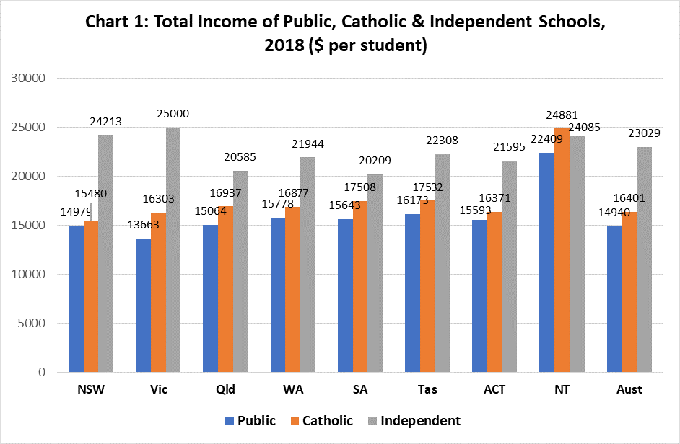

Enrolment Statistics.
Funding statistics are contestable, especially when indirect grants or taxation exemptions are excluded. But enrolment statistics are not.
In 2018, public schools enrolled 82% per cent of all low SES students; 84% of Indigenous students, 77% of high disability students and 82% of remote area students [Chart 4]. Disadvantaged students accounted for 46% of all public school enrolments compared to 20% in private schools.
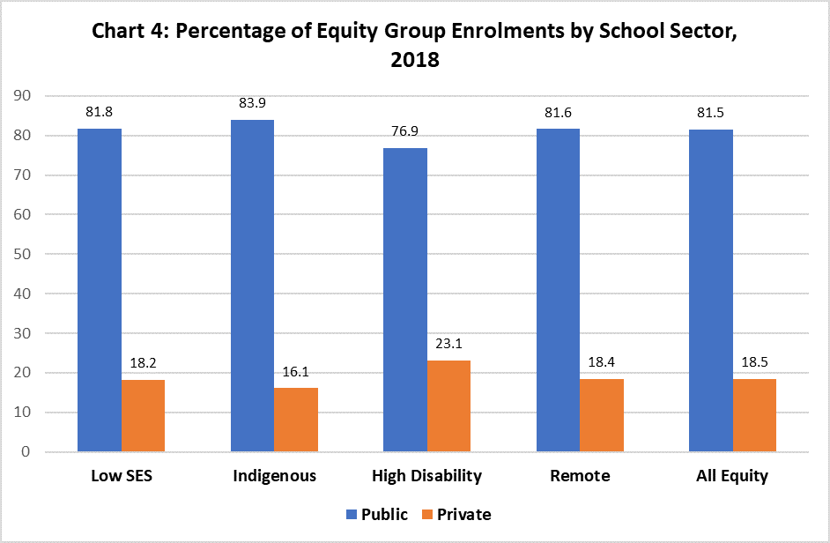

95% of schools with 50% or more students from the lowest socio-economic status (SES) quartile were public schools, 3% were Catholic schools and 2% were Independent schools
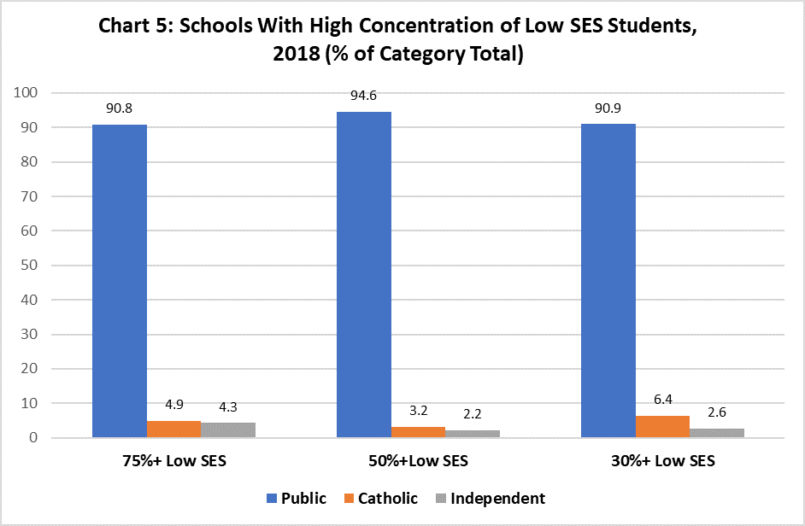
So, as noted above, according to economist Adam Rorris (former advisor to the Australian Government and the World Bank), Australian public schools which enrol the vast majority of disadvantaged students will miss out on at least 19 billion in funding over the next four years, while he Federal Government will also overfund the wealthiest private schools by over $1 billion by 2023. And, while they have put a limit on funding for public schools, there is no maximum amount of funding set for private schools.
The following table drawn up from the MYSCHOOL website illustrates the distribution of resources available to various private and public schools in Melbourne.
RECURRENT FUNDING OF SELECT VICTORIAN PRIVATE AND PUBLIC SCHOOLS
 | ICSEA value
 | Index of |  |  | 2018 |  |  | Per Student
SCHOOL | community |  | State | Federal | private | Total | $
 | socio-economic |  | $million | $million | $million | $million
 | advantage
Geelong | 1152 | Corio | 1.001 | 6.981 | 30.887 | 40.972 | 27,948
Grammar
Scotch | 1191 | Hawthorn | 1.336 | 5.288 | 58 | 65 | 31,666
Wesley | 1159 | Prahran | 2.221 | 11.393 | 99.123 | 115.51 | 31,597
Xavier | 1179 | Kew | 1.091 | 6.981 | 30.887 | 38.959 | 26,473
Haileybury | 1179 | Keysborough | 3.757 | 24.688 | 93036 | 127 | 30,130
Ivanhoe Grammar | 1145 | Ivanhoe | 1.428 | 11.498 | 52.369 | 87 | 37,738
Acquinas | 1065 | Ringwood | 3.843 | 15.001 | 11.366 | 30.888 | 30,888
De La Salle | 1114 | Malvern | 2.006 | 7.702 | 12.139 | 22.519 | 20,196
Kilbreda | 1060 | Mentone | 2.019 | 7.922 | 5.734 | 16.062 | 17.197
Parade College | 1059 | Bundoora | 4.537 | 18.368 | 12.849 | 29.763 | 16.098
Simonds College | 1015 | West Melb. | 1.4672 | 5.167 | 1.314 | 7.988 | 18,363
Al Noor Muslim College | 1024 | Greenacre | 4.363 | 15.121 | 4.938 | 25.317 | 13,933
University High School | 1132 | Parkville | 14.156 | 3.267 | 1.452 | 19.88 | 13.837
Melbourne High School | 1168 | Sth Yarra | 12.605 | 2.982 | 4.426 | 21.355 | 15,753
Whittlesea Secondary College | 956 | Whittlesea | 2.034 | 8.696 | 0.245 | 11.285 | 11,700
Hoppers Crossing Secondary | 968 | Hoppers Xing | 16.279 | 3.803 | 0.491 | 20.657 | 14,043
Shepparton High School | 924 | Shepparton | 7 | 1.6 | 0.437 | 9.1 | 17,977

A growing body of evidence indicates that the primary educational objective of the private systems of Australia have never been the ‘needs’ of disadvantaged children in their care but what Malcolm Turnbull, in his recent Memoir has described as maintaining ‘enrolments in middle-class areas’. If this is the case, the non-Catholic denominations and not the major Catholic systems have been the big winners.
The following graph and table based on statistics from the Australian Bureau of Statistics, and published with pride on the Independent School website illustrates the point.
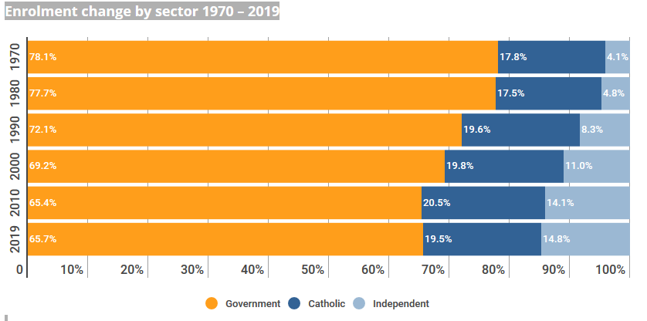
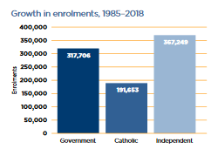
The following table illustrates the growth of way in which Australian children have been increasingly divided on ethnic and religious criteria since 1980
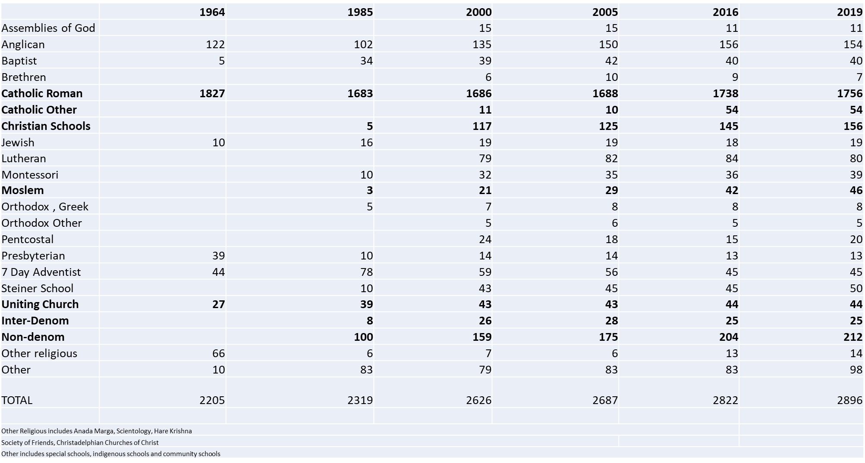

Karmel’s Explanation of Failure:
In 1998, twenty five years after his much publicised Report, Peter Karmel, an erstwhile economist, was the honoured speaker at an ACER Conference entitled 1998 - Schools in Australia: 1973-1998 The 25 years since the Karmel Report. Reflecting on these years he said:
The period since Schools in Australia was published has been one of great change:
We now live in an economy with a strong market orientation and one which has undergone an information-technological transformation. …..
The economic paradigm has undergone a quantum shift: from the ideal of a mixed economy of the post World War II era to one subject to the principles of ‘economic rationalism’. This has been accompanied by a decline in the willingness of governments to devote resources to education.
He completed his talk with the statement that if Australia wished to raise retention rates to 100% and add a system of entitlement to a quantum of post-school education, then the community
Will have to be willing to devote more resources to education. The price of this may well be higher taxation. We need to signal to governments that, if the price is higher taxation then so be it.
At the same Conference Bob Lingard from the University of Queensland. He pointed to the simple fact that the problem of injustice in education had not been solved. He said:
I am ..convinced that this is not just a problem for the ‘disadvantaged.’ Perhaps the greatest weakness of compensatory education was its centrifuging tendency, the way it turned our eyes away from the education of the privileged.
I consider that a privileged education is, by the very fact or privilege, a corrupt education. For too long we have let the privatisers persuade us that there is something admirable about grabbing more resources than your neighbour has. An education designed to select and exclude, and to give advantages in this selection and exclusion, undermines the moral basis of communication, culture and social life. …
As Lingard noted, at no point since 1973 have high fee schools been confronted or lost a dollar of public funding. Nor has any politician successfully confronted either the schools for the wealthy or the use of block public funding with minimal accountability by the major private sector – the Catholic church.
Neither Karmel nor Gonski solved the inequality problem in education. They were unable to make unequally wealthy institutions permitted to select children on economic or any other criteria, equally available to all children Neither of them were permitted by their terms of reference, to confront the ‘privileged’ as well as the ‘disadvantaged.
Karmel’s claim that the zeitgeist, the times, the economic paradigm had changed leads to the work on inequality done by international political economists in the twenty first century.

The Success: Persistence of the Idea of Equality
Why has the Idea Survived the obvious Realities?
- A Perennial Ideal:
Political economists alongside public education researchers in Australia have kept the ideal of equality alive and kicking in 2020. But the idea is an ancient one.
The Greeks understood the implication of ‘equality’ implication for stable government. In December 2014, The Australian Senate Community Affairs References Committee Report, Bridging our Growing Divide: inequality in Australia quoted Plato as follows:
…..In a state which is desirous of being saved from the greatest of all plagues – not faction but rather distraction – there should exist among the citizens neither extreme poverty nor again, excessive wealth, for both are productive of great evil…Now the legislator should determine what is to be the limit of poverty or of wealth.
For Aristotle, ‘…inequality is the chief cause of revolution. Justice and equality are “the fundamental basis of any state”, and inequality, being a kind of injustice, is potent grounds for challenging that state.
Early Christians were revolutionaries. The apostle Paul said:
So in Christ Jesus you are all children of God through faith …. There is neither Jew nor Gentile, neither slave nor free, nor is there male and female, for you are all one in Christ Jesus.
A legacy of the Age of Enlightenment, the motto "Liberté, Egalité, Fraternité" first appeared during the French Revolution. Although it was often called into question, it finally established itself under the Third Republic.
The concept of equality foremost in the American Declaration of Independence. But it was not transferred into the Australian Eureka oath.
We hold these truths to be self-evident, that all men are created equal, that they are endowed by their Creator with certain unalienable Rights, that among these are Life, Liberty and the pursuit of Happiness.
But the idea went missing in Australia.
'We swear by the Southern Cross to stand truly by each other and fight to defend our rights and liberties!' The diggers' oath, 30 November 1854.
At issue in both the United States and Australia was taxation –which neither party wished to pay. Yet taxation is one way of redistributing wealth.
It should be noted, and has been noted by the 21st century political economists mentioned later in this paper, that neither the Europeans, nor the British in North America and Australia have ever seriously considered redistribution of income or wealth. Nor has equality of opportunity in educational provision been a possibility since the days of the Enlightenment, with perhaps the exception of the Scandinavian countries.
One thing however, there is agreement upon.
There is broad agreement that for most countries, including Australia, there was a tendency for inequality in the distribution of income and wealth to grow up until 1913, to fall fairly continuously until 1980, and then to grow again.
Twenty first century political economists:
Educational systems both reflect and influence social, political and economic development. Karmel, and to a lesser extend Gonski knew that. But Commissions of enquiry have concentrated on education for the poor rather than that of the privileged, the upper one and ten percent.
In a parallel universe to academic historical enquiry, another literature takes up the challenge of exploring the global history of inequality for the upper one and ten percent, attempting to identify forces of levelling or increasing distribution of income and wealth across recorded history. Until recently this may have been a niche study, but since the turn of the century it has become a subject of intense international study.
At least one Australian academic turned policy adviser and politician, Andrew Leigh, has taken up this challenge. He asks the question : What drives inequality in Australia? in a series of academic articles and in his 2013 Battler and Billionaires. Leigh was an economics professor at the ANU, not an historian. Yet his book presents a socio-economic interpretation of Australian history.
He argues that, after more than century of high inequality – from English settlement to World War 1, inequality in Australia – as in many other parts of the world – fell for about half a century. He calls this ‘The Great Compression’. But, in the past generation, since about 1980, Australia’s level of inequality now ranks towards the upper end. This is known as the ‘Great Divergence’. A recent OECD comparison finds that Australia has the nineteenth highest level of inequality among forty nations. South Africa and the Latin American countries tend to be among the most unequal, followed by English speaking nations (with the USA leading that group) The most equal of all are the Scandinavian nations.
In Australia Andrew Leigh has been joined by Victorian economists, Michael Schneider, Mike Pottenger and J.E. King in 2016. And in 2017 Tony Ward, published an article entitled ‘Inequality and Growth: Reviewing the Economic and Social Impacts’ in The Australian Economic Review. Ward reviewed the now extensive literature on the effect of inequality on economic growth. He concluded that, while specifics vary with circumstances, in most areas, increases in inequality have negative impacts on economic growth.
Australian economists tracing the history of inequality are part of a much wider global academic movement, including Andrew Leigh’s collaborator and mentor, the late A.B. Atkinson at Oxford; Richard Wilkinson and Kate Pickett, whose work has influenced Tony Ward are epidemiologists who, linking medical evidence with income inequality data, highlight the "pernicious effects that inequality has on societies: eroding trust, increasing anxiety and illness, (and) encouraging excessive consumption" ; Thomas Piketty at the School of Economics in Paris; Joseph Stiglitz, the Chief economist at the World Bank until January 2000 and Columbia Business School; New York ,and Harvard; Paul Krugman from City University of New York and columnist at the New York Times; and Robert Gordon an economic historian from North western University. All the above writers look into the entrails of their graphs describing the scale of the problem. Talk about the 99% and the billionaire 1% has become entrenched in public debate. They all agree that, although inequality was curbed in the decades after World War 11, since 1980 it has returned with a vengeance. But they are not skeptics. They argue that unequal societies do not function effectively and their economies are neither stable nor sustainable.And Levels of inequality impact the economy, the health of individuals, the cohesiveness of society and the proper functioning of the polity. They wish to influence policy, rather than predict the future. For them, inequality is not and never was, inevitable.
Some Australian policy analysts do consider inequality of any consequence where incomes of high-income individuals increase without decreasing the incomes of others. Chris Berg, a commentator with the Australian Institute of Public Affairs considers that the economic danger of the twenty first century is not inequality but slow economic growth. His views echoed those of Harvard Professor Felstein, a former adviser to President Ronald Reagan.
Walter Scheidel, on the other hand, is determinist, if not apochrophal. Going back into pre-history and tracing it through the Holocene to the present time, he points out that ‘high inequality has an extremely long pedigree’. For example, he notes that the American billionaire class, the ‘1 percent’ top income shares have only very recently caught up with those reached back in 1929 and assets are less heavily concentrated now than they were then. While, in England on the eve of the First World War, the richest tenth of households held 92 % of all private wealth, while in 201 ??? their share is little more than half. His 2018 book The Great Leveller: Violence and the History of Inequality from the Stone Age to the Twenty-First Century, tackles the big, big picture, a
global survey that covers the broad sweep of observable history. A cross-cultural, comparative, and long-term perspective essential for our understanding of the mechanisms that have shaped the distribution of income and wealth.’
Scheidel, argues that the only forces that can seriously decrease economic inequality are mass violence and catastrophes. The frontierspiece of his book opens to a picture of Albrecht Durer’s The Four Horsemen of the Apocalypse. Scheidel’s four horsemen are: mass-mobilisation warfare; transformative revolutions; state collapse; and last but not least, catastrophic plagues. He argues that these are the only forces in human history, which have repeatedly destroyed the fortunes of the rich.
These are big and bigger picture writers, bridging the divide between different areas of specialisation both with and beyond academic disciplines in their attempt to overcome disparities in the quality and quantity of data. But I wish to label them political economists. Sometimes they label themselves macroeconomists because they deal with both philosophical questions and centuries of economic data. I regard them as renewing a long tradition going back at least to the Scottish Enlightenment and Adam Smith, or even further back to Plato and Aristotle. All of the above writers have been influential in the corridors of power as policy analysts, and their work is echoed in at least four OECD Reports. They produce and share international data on at least two websites: the WID (World Inequality Data ) and the UNESCO World Inequality Report.
On the basis of statistical data, most twenty first political economists agree on one thing. In the Western democracies, the share of the top decile (the 10 percent of the population with the highest incomes) amounted to anything up to 50 percent of total income in the nineteenth century up until World War 1. It then began a chaotic fall between 1914 and 1945, eventually stabilising at around 10 percent of total income in 1945-1950 where it stayed until 1980. In The United States income inequality was below that of Europe until 1914, but exceeded that in Europe during the so-called Trentes Glorieuses (1950-1980) . And the revival of inequality since 1980s has been much stronger in the United States than in Europe or Australia . The following graphs illustrates these developments:

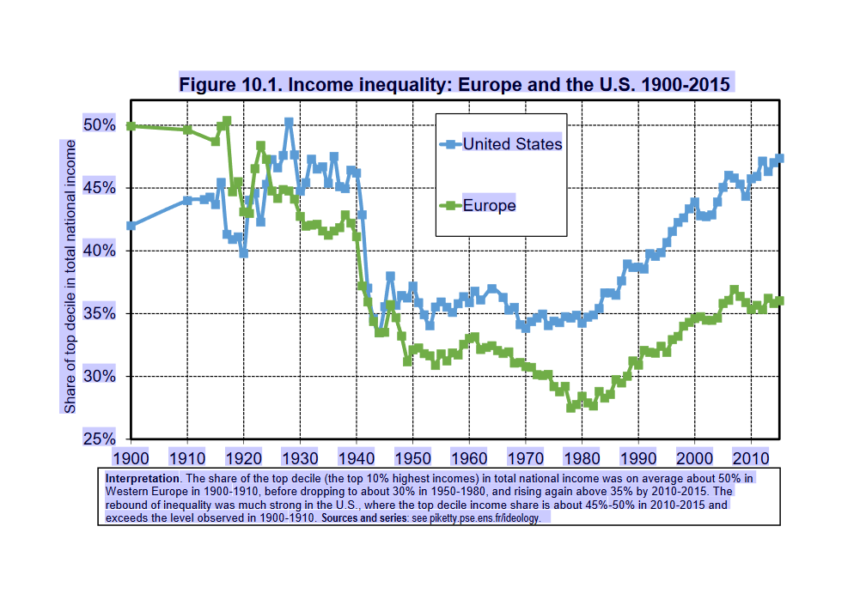
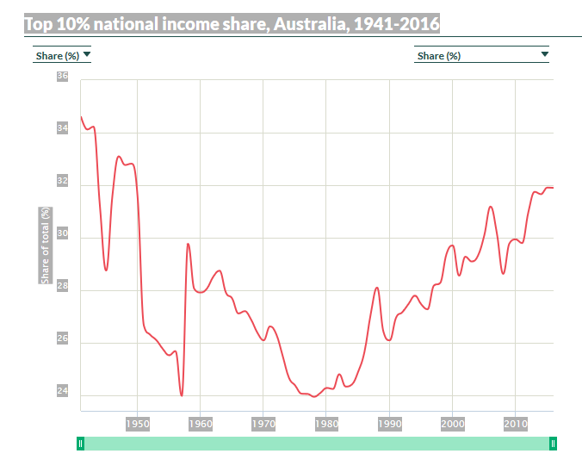

A recent OECD comparison finds that Australia has the nineteenth highest level of inequality among forty nations. South Africa and the Latin American countries tend to be among the most unequal, followed by English speaking nations (with the USA leading that group) The most equal of all are the Scandinavian nations.

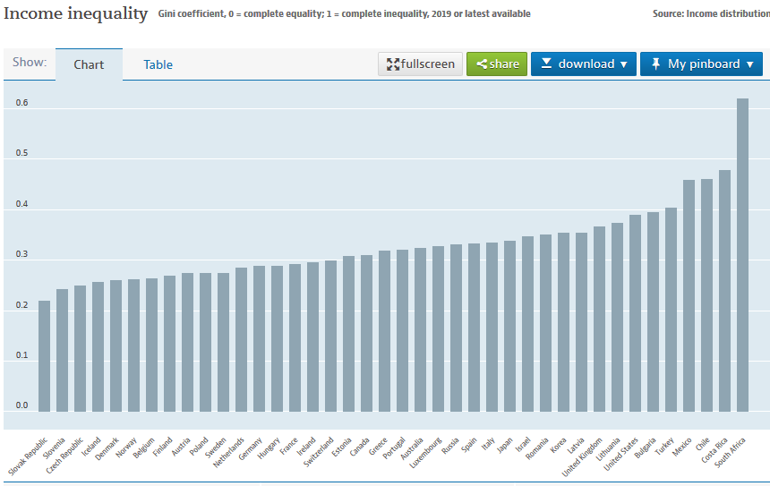
Economists have seldom considered distributional or inequality issues of central interest. Some believe that the economics profession should not concern itself at all with inequality. This was expressed forcefully by the Nobel Prize-winner Robert Lucas of the University of Chicago:
Of the tendencies that are harmful to sound economics, the most seductive, and in my opinion the most poisonous is to focus on questions of distribution….The potential for improving the lives of poor people by finding different ways of distributing current production is nothing compared to the apparently limitless potential of increasing production.
In Australia Andrew Leigh has been joined by Victorian economists, Michael Schneider, Mike Pottenger and J.E. King in 2016. And in 2017 Tony Ward, published an article entitled ‘Inequality and Growth: Reviewing the Economic and Social Impacts’ in The Australian Economic Review. Ward reviewed the now extensive literature on the effect of inequality on economic growth. He concluded that, while specifics vary with circumstances, in most areas, increases in inequality have negative impacts on economic growth.
Australian economists tracing the history of inequality are part of a much wider global academic movement, including Andrew Leigh’s collaborator and mentor, the late A.B. Atkinson at Oxford; Richard Wilkinson and Kate Pickett, whose work has influenced Tony Ward are epidemiologists who, linking medical evidence with income inequality data, highlight the "pernicious effects that inequality has on societies: eroding trust, increasing anxiety and illness, (and) encouraging excessive consumption" ; Thomas Piketty at the School of Economics in Paris; Joseph Stiglitz, the Chief economist at the World Bank until January 2000 and Columbia Business School; New York ,and Harvard; Paul Krugman from City University of New York and columnist at the New York Times; and Robert Gordon an economic historian from North western University. All the above writers look into the entrails of their graphs describing the scale of the problem. Talk about the 99% and the billionaire 1% has become entrenched in public debate. They all agree that, although inequality was curbed in the decades after World War 11, since 1980 it has returned with a vengeance. But they are not skeptics. They argue that unequal societies do not function effectively and their economies are neither stable nor sustainable.And Levels of inequality impact the economy, the health of individuals, the cohesiveness of society and the proper functioning of the polity. They wish to influence policy, rather than predict the future. For them, inequality is not and never was, inevitable.
Some Australian policy analysts do not consider inequality of any consequence where incomes of high-income individuals increase without decreasing the incomes of others. Chris Berg, a commentator with the Australian Institute of Public Affairs considers that the economic danger of the twenty first century is not inequality but slow economic growth. His views echoed those of Harvard Professor Felstein, a former adviser to President Ronald Reagan.
Walter Scheidel, on the other hand, is determinist, if not apochrophal. Going back into pre-history and tracing it through the Holocene to the present time, he points out that ‘high inequality has an extremely long pedigree’. For example, he notes that the American billionaire class, the ‘1 percent’ top income shares have only very recently caught up with those reached back in 1929 and assets are less heavily concentrated now than they were then. While, in England on the eve of the First World War, the richest tenth of households held 92 % of all private wealth, while in 2015 their share is little more than half. His 2018 book The Great Leveller: Violence and the History of Inequality from the Stone Age to the Twenty-First Century, tackles the big, big picture, a
global survey that covers the broad sweep of observable history. A cross-cultural, comparative, and long-term perspective essential for our understanding of the mechanisms that have shaped the distribution of income and wealth.’
Scheidel, argues that the only forces that can seriously decrease economic inequality are mass violence and catastrophes. The frontierspiece of his book opens to a picture of Albrecht Durer’s The Four Horsemen of the Apocalypse. Scheidel’s four horsemen are: mass-mobilisation warfare; transformative revolutions; state collapse; and last but not least, catastrophic plagues. He argues that these are the only forces in human history, which have repeatedly destroyed the fortunes of the rich.
These are big and bigger picture writers, bridging the divide between different areas of specialisation both with and beyond academic disciplines in their attempt to overcome disparities in the quality and quantity of data. But I wish to label them political economists. Sometimes they label themselves macroeconomists because they deal with both philosophical questions and centuries of economic data. I regard them as renewing a long tradition going back at least to the Scottish Enlightenment and Adam Smith, or even further back to Plato and Aristotle. All of the above political economists have been influential in the corridors of power as policy analysts, and their work is echoed in at least four OECD Reports. They produce and share international data on at least two websites: the WID (World Inequality Data ) and the UNESCO World Inequality Report.
On the basis of statistical data, they all agree on one thing. In the Western democracies, the share of the top decile (the 10 percent of the population with the highest incomes) amounted to anything up to 50 percent of total income in the nineteenth century up until World War 1. It then began a chaotic fall between 1914 and 1945, eventually stabilising at around 10 percent of total income in 1945-1950 where it stayed until 1980. . The United States income inequality was below that of Europe until 1914, but exceeded that in Europe during the so-called Trentes Glorieuses (1950-1980) . And the revival of inequality since 1980s has been much stronger in the United States than in Europe or Australia . The following graphs illustrates these developments:

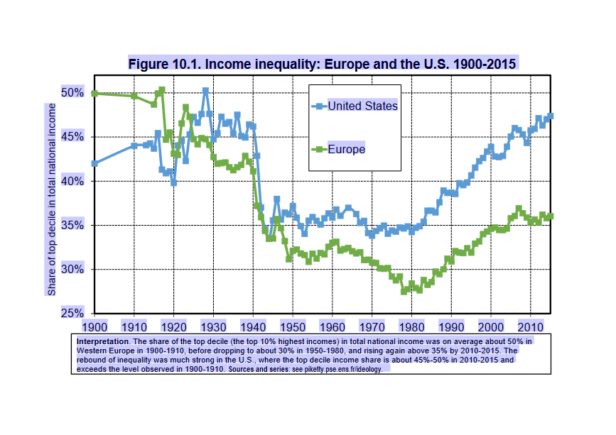

WORLD INEQUALITY DATABASE https://wid.world/country/australia

It could be argued that, politically, Karmel and Gonski were given an impossible task. In the last forty years, the compensatory education model introduced by both the Schools Commission and Gonski has been severely undermined by a selective, denominational system inherited from the eighteenth century alongside an academically selective public system. For political reasons, the denominational system has been resuscitated and favoured by successive federal governments.
Reasons for Increases in Inequality 1980-2020
Andrew Leigh argues that the big factors driving recent changes in thelevels of inequality are technology, globablisation (which has combined to created ‘suprstar’ CEOs), a collapse in union membership, taxation and education.

But the political economist whose historical interpretation of these increases in ‘inequality’ in the last forty years I wish to explore is Thomas Piketty, mainly because he is interested, not only in inequality data, but in his latest book, Capitalism and Ideology, the history of ideas. It is the historical interpretations of inequalities in the last millenium rather than his political and policy recommendations which I wish to use as a searchlight on the Karmel and Gonski failures to extend educational – and social mobility opportunities to large numbers of Australian children.
Like Karmel and Gonski, Andrew Leigh, and other political economists, Picketty assumes, philosophically, that inequality is a bad thing. It offends moral sensibilities. But he goes further. He claims that inequality is illegitimate, and therefore leans on ideologies in order to be justified by ruling elites.
He claims that “All history shows that the search for a distribution of wealth acceptable to the majority of people is a recurrent theme in all periods and all cultures”. As societies distribute income, wealth and education more widely, so they become more prosperous. The overturning of regressive ideologies is therefore the main condition of economic progress.
He describes the justification of inequalities in pre-modern “Ternary societies” (such as feudalism) that were divided into clerical, military and peasants of ‘the third estate’. He argues that over the 18th century “Ownership societies” becoming dominant by the end of the 19th century concentrated income and wealth in the hands of landowning families and the new bourgeoisie and ‘sacralised’ the ownership of property. “Slave societies” offered the most extreme model of inequality. “Colonial societies” had various combinations of military power, bourgeois ownership and slavery. The Utopian ideal of complete equality promoted in Communist and post-communist societies fostered poverty, stagnation and rampant inequality in oligarchical Russia.
His story of shifting “inequality regimes” within the liberal west partly repeats his account in Capital in the Twenty-First Century. Despite the avowed egalitarianism of the French Revolution, wealth and income inequality remained high throughout the 19th century, until the First World War. But the combination of two world wars, a depression and progressive taxation with high marginal tax rates and death taxes, led to dramatic falls of wealth concentrated in the upper 1% and 10% of the Western democracies. Greater equality set the stage for social democratic regimes of the second half of the twentieth century.
But since 1980, what Picketty describes as ‘hypercapitalism’ or the return of the nineteenth century proprietarian system is producing concentration of wealth not witnessed since the Belle Epoque, before the First World War
The data on OECD, and WID websites together with those produced in the work of Australian political economists, indicate that Australia was very much part of this political economic history.
I wish to ‘cherry pick’ four of Picketty’s reasons for the failure of twentieth century social democratic regimes to prevent the current rise in inequality, in Australia generally, and education in particular .
- Unequal Education and Political Consequences
Picketty, like Karmel, views the unequal access to education, and in particular tertiary education, as a lurking weakness in the social democracies of Europe, the United States and Australia. Increased levels of education are a major factor in productivity, economic development and property rights. The sharp division between graduates and non-graduates, he argues, has created a “Brahmin” left; a ‘merchant right’ and an anxious, electorally itinerant class
- Progressive Taxation
First, Picketty, like Karmel, has pointed to taxation, as central to the inequality story. In particular he argues that a progressive tax system was responsible for the rise of social democratic regimes like Australia which lowered inequality in the period 1950 to 1980. The abandonment of this system has led to rising inequalities.
- Failure of the Brahmin Left to Confront Privilege
Picketty’s account of the past 40 years is less a story of capital being unleashed than of progressive ideologies running out of steam. The Australian version of what Picketty calls the ‘Brahmin’ left have never confronted the ‘neo liberal ‘market ideology, most particularly in education. They have favoured ‘cultural diversity’ but failed to tax the wealthy to pay for it.
- The Strength of the Meritocratic Ideology
Picketty’s view of the part played by the ‘meritocratic’ ideology is of particular interest in the Australian public – as well as private school setting.
- Unequal Education and Political Consequences
The advent of the era of higher education has posed a structural challenge to the very idea of educational equality everywhere. Picketty notes that no country has responded successfully to the transition from the first educational revolution to the second, namely from the revolution in primary and secondary education to that in the tertiary sector. He goes further:
‘This failure is the reason why inequality has risen since 1980 and why the social-democratic model seems to have run its course.’
And it is striking to note that public spending on education, which increased rapidly over the course of the twentieth century from barely 1 -2 percent of national income in 1870-1910 to 5-6 percent in the 1980s, then plateaued in the countries of Western Europe, and the United States.
In Australia it not only stagnated, but was reduced. The average value for Australia during that period was 5.15 percent with a maximum of 6.01 percent in 1978 and a minimum of 4.64 percent in 2008. The latest value from 2016 is 5.27 percent. For comparison, the world average in 2016 based on 106 countries was 4.55 percent.
In his discussion of the search for educational and social justice, Picketty confronts the ‘specific problem posed by the coexistence of public and private schools, not only at the tertiary, but also at the primary and secondary levels. He notes that private schools benefit from direct or indirect public financing because they enjoy special legal and fiscal status. However, they participate in the provision of an essential public service, namely the dissemination of knowledge to the young. He therefore considers that they
should be subject to the same regulations as public schools with respect to both available resources and admissions procedures. Otherwise the effort to construct acceptable norms of justice in the public sector will be undermined by flight to the private sector.
- Progressive Taxation
In the period 1950-1980, the ‘golden period’ of social democracy, income equality settled at a level noticeably lower than in previous decades in the European , American – and Australian democracies.
The dramatic rise of progressive income and inheritance taxes in the period 1914-1945 in Europe, the USA and Australia, was an emergency response to the collapse of what Picketty terms ‘ownership’ or ‘proprietarian’ societies during war and depression. It fuelled the nationalisations, public education, health and pension reforms, but was never fully integrated into fiscal policy by the twentieth century social democratic parties. There was little or no resistance to the challenges raised against progressive taxation in the 1980s. In Australia the Labour Party under Hawke and Keating adopted the new market paradigm.
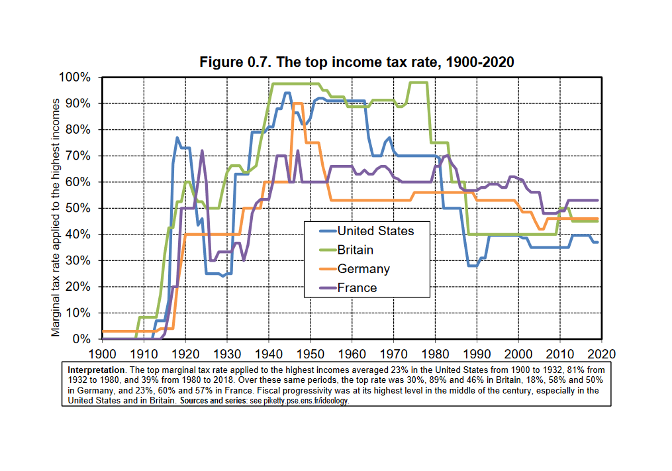
http://piketty.pse.ens.fr/files/ideology/pdf/F0.7.pdf
The Australian story does not deviate from this graph. Cuts to the top tax rate in the past generation mirrors the global trend.
Colonial governments were dependent upon import taxes (tariffs) and land sales for revenue. Inheritance taxes were first levied in 1868; land taxes (1878) and income taxes (1880) but total revenue from state and federal income taxes remained below that from tariffs until 1941 when World War II when the States referred their income taxing powers to the federal government.
From 1942 to 1944 the top tax rate peaked at 93 percent. The highest rate paid by the top 1 per cent peaked at 65 percent in 1975. It fell to 60 per cent in the 1980s, to 47 per cent in the 1990s and is currently 45 per cent. Inheritance taxes were abolished in the 1980s, in 1999 capital gains tax on assets held for more than a year were halved, and a goods and services tax introduced in 2000. State and federal inheritance taxes were abolished in the late 1970s.
The company tax rate dropped from 46 per cent in 1980 to 30 per cent in 2013. It is now 27.5% for a company with an aggregated turnover less than the aggregated $50 million for the 2019–20 income year
For high income earners, a generation of reforms to broaden the base and lower the rate has been a bonanza. Based on his 2013 research with Sir Tony Atkinson Andrew Leigh estimates that one third of the rise in top incomes over the last forty years is due to cuts in top tax rates.

http://piketty.pse.ens.fr/files/ideology/pdf/F11.11.pdf
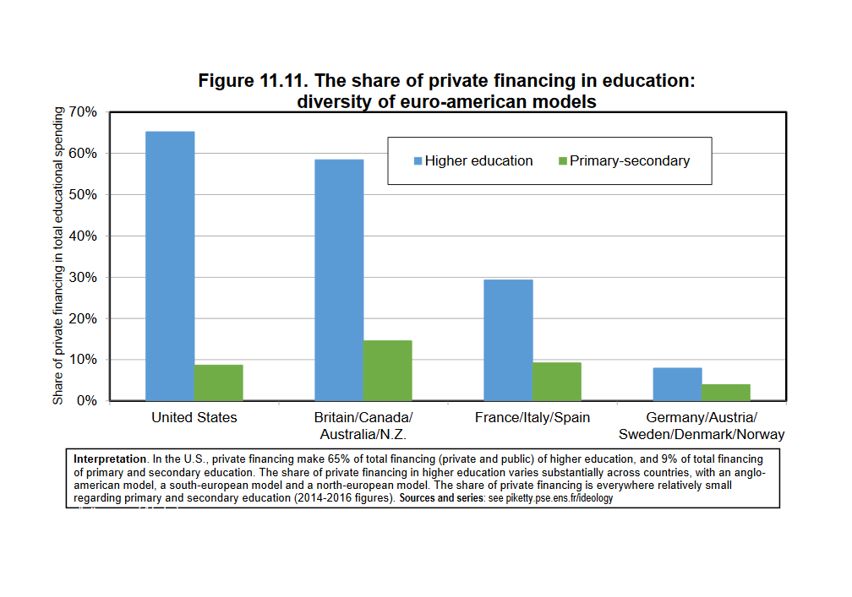
3. The Brahmin Left
The history of the last forty years, for Picketty, is the failure of ‘social democrats’ to solve the issue of ‘just’ public and private ownership of property, progressive taxation and power sharing in employment, after the collapse of the Soviet Union. He considers the ideology built on equal opportunity in education, was hypocritical, particularly at the tertiary level, and glorified winners in the educational sweepstakes. The failure of social democrats to persuade the disadvantaged that they cared not only about elite institutions for their own children, but also about schools for the rest, in part explains why leftist parties have become parties of the educational elite, leaving behind disaffected voters from the lower orders.
Picketty calls this educated elite ‘The Brahmin Left’.
In Chapters 14 -16 of Capitalism and Ideology, he traces cleavages in political and electoral voting patterns throughout western democracies. From 1960-1980, the vote for left-wing parties (labour, social-democrats, socialists, communists, radicals, greens, etc.) was associated with voters with the lowest education levels; in the period 2000-2020, it has become associated with those with the highest diplomas. This general evolution happened in the U.S. and in Europe, as well as in Canada, Australia and New Zealand.
The following graphs indicate the difference between the percentage vote for left-wing parties among the top 10% education voters and the bottom 90% education voters.
http://piketty.pse.ens.fr/files/ideology/pdf/F16.1.pdf

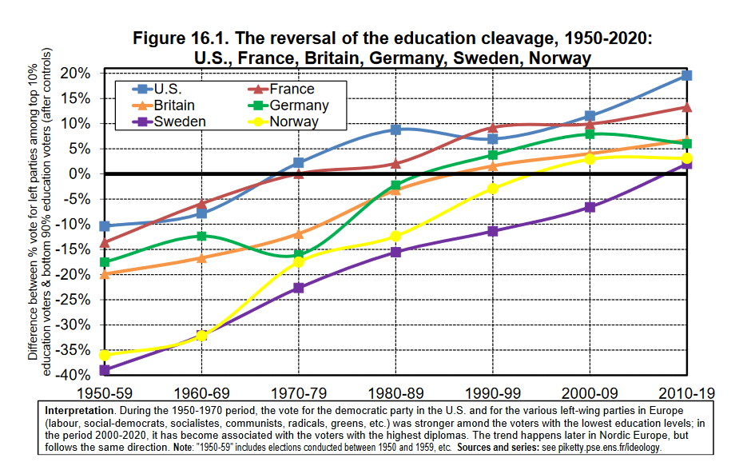

http://piketty.pse.ens.fr/files/ideology/pdf/F16.2.pdf

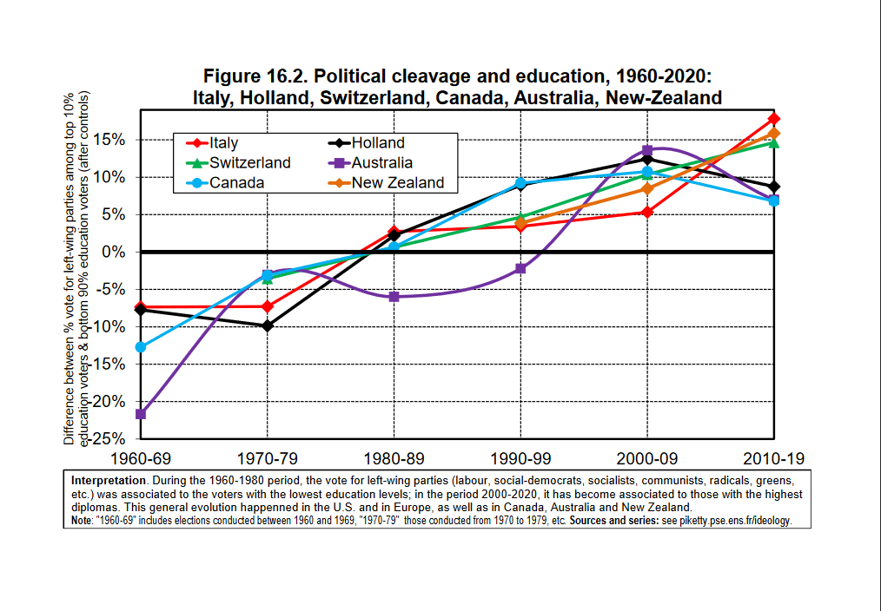

Picketty is French, and, although he takes an historical and global perspective, his concepts are forged in the French situation. He argues that in 1980s France,
with the end of Soviet communism and bipolar confrontations over private property, the expansion of educational opportunity and the rise of the ‘Brahmin left’, the political-ideological landscape was totally transformed.
A dual-elite emerged, The ‘Brahmin Left’ attracting the votes of the highly educated, and a’ merchant right’ the party of highly paid and wealthier voters. The ‘Brahmin left’ voters believe in rewarding scholastic effort and talent while the ‘merchant right’ voters emphasise business talent. ‘Brahmin left’ seeks to accumulate diplomas, knowledge, and human capital; the merchant right accumulates cash and financial assets. The ‘Brahmin left’ may prefer higher taxes but both camps are strongly attached to the existing economic system and globalisation.
These dual elites legitimate levels of inequality, and for Picketty, they represent a return to premodern, pre French revolution trifunctional, societies based on power sharing between intellectual and warrior elites, except that warriors are replaced by merchants because security of goods and persons is now assured by the centralised state. The ‘Brahmin left’ are themselves divided between the pro-market centre-left and those who favour wealth re-distribution and answers to the challenge of rising inequality. The ‘merchant right’ Picketty believes have also split into a pro-market centre right and a nativist right.
Picketty claims that this same ‘cleavage structure’ has appeared in the United States, the United Kingdom and other Western countries – including Australia. It is leading to political instability.
The following diagram illustrates his point:

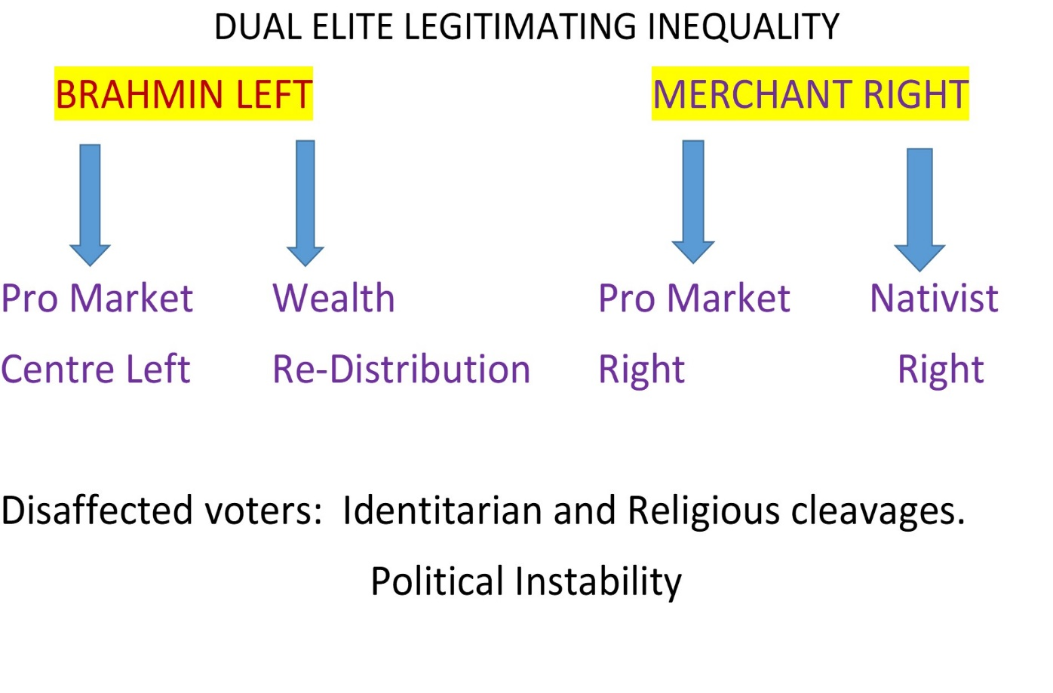

This interpretation of political developments in the Western democracies during the last half century is contestable. Yet it makes some sense of what has happened to the political and educational landscape in Australia since 1973.
Both Whitlam and Hawke can be seen as members of the new ‘Brahmin Left’, a highly educated class. So were many members of their ministries. And so was Karmel and his colleague, Jean Blackburn. In 1983 the Hawke Labour Government enthusiastically embraced the neo-liberal ideology as well as newly minted billionaires like Alan Bond. At no stage did a labour government confront or solve escalating inequities in educational funding until 2010 when Gillard tried. But she turned to a doyen of the ‘merchant right’ David Gonski and decreed that ‘No school would lose a dollar’.

4. The Strength of the Meritocratic Ideology
Thomas Picketty argues that official meritocratic discourse masks the reality of unequal access to education while enabling winners in the education stakes to blame the losers from lacking talent, virtue, and diligence. He writes;
Modern inequality also exhibits a range of discriminatory practices based on status, race, and religion, practices pursued with a violence that the meritocratic fairy tale utterly fails to acknowledge. In these respects, modern society can be as brutal as the premodern societies from which it likes to distinguish itself.
In 2013 Boris Johnson, the British Prime Minister, graduate of Eton and Oxford articulated the Meritocratic justification of inequality in both society and educational provision. In the third ‘Margaret Thatcher Memorial lecture’ he argued that some people are simply too stupid to catch up with the rest of society. He said:
Whatever you may think of the value of IQ tests it is surely relevant to a conversation about equality that as many as 16 per cent of our species have an IQ below 85.
He compared society to a box of cornflakes,:
the harder you shake the pack, the easier it will be for some cornflakes to get to the top…(inequality) is essential for the spirit of envy and keeping up with the Joneses that is, like greed, a valuable spur to economic activity…..
– no one from Paul Krugman to Joe Stiglitz to Will Hutton, let alone Ed Miliband – has come up with any other way for an economy to operate except by capitalism…. Ding dong! Marx is dead. Ding dong! communism’s dead. Ding dong! socialism’s dead! Ding dong! ….
Like it or not, the free market economy is the only show in town. Britain is competing in an increasingly impatient and globalised economy, in which the competition is getting ever stiffer.
Boris Johnson’s view may contain echoes of the eugenics movement of the nineteenth century, but the meritocratic justification of separating educational winners and losers is firmly embedded in the history of both public and Catholic education in Australia.
The most articulate and committed expositor of ‘meritocracy’ in the early years of the twentieth century was the NSW Department of Education director Peter Board. In August 1913, Board delivered a lecture before the members of the Secondary Teachers’ Association. He compared the American and Australia systems, favouring the selective, stratified Australian public system. He complained that, although the Americans boasted of their democracy, to his mind, they were running a most undemocratic high school system. They were employing the funds of the state to run high schools into which everyone could enter irrespective of the fact that many of them did not make an adequate return to the state for the public money spent on them.
I feel justified in saying that there are greater facilities provided for the education of those who are worth it in New South Wales than in any other country in the world. The system operating here is one by which I hope to see brought into the position of leaders in our community many of those boys and girls who possess great capacity and ability. They will be pupils who will be worth educating, and who will be able to get the kind of education that they need. The system of individual endowment is now being carried into the university, and no scheme of education is complete which will not give the best intellects of the State their best opportunities. From my observation of the American high schools there is a great deal to justify the criticism that they tend towards superficiality. The schools have been brought down to the mediocre level of the pupils.
The development of catholic secondary education represented a parallel rather than a contrast to state secondary education. In Melbourne, by 1918,. He promoted the establishment of a Catholic College at the University of Melbourne and a system of scholarships in order that:
… no Catholic man will be precluded from sending his son to the university, if only his son has the talent to avail himself of university training and give a good return for the public money expended on him.
Archbishop Mannix was promoting a system of meritocracy in catholic secondary education which had more in common with Board’s system in New South Wales than might be expected. He exhorted his flock to turn out men into the ‘professions, commerce, and public life who would be staunch Catholics and good Australians’
St Kevin’s College, Toorak, officially opened in 1918, was run by the Christian Brothers who were expected to train the talented Catholic youth for the university.
It is suggested that many upwardly mobile or upper class Australian parents have proved reluctant to enrol their ‘clever little cornflakes’ in schools frequented by those of the lower orders with below average IQs, particularly at the secondary level. Most public systems in Australia have retained and even expanded the old selective and specialist high schools established by Peter Board in 1912. And, since ‘free’ public education is a right for the indigent only, comprehensive high schools in wealthier suburbs are better appointed than those in poorer suburbs.
In 1961, the introduction of Wyndham’s comprehensive high school reform in New South Wales undermined the meritocratic, stratified selective system. The resuscitation of the private, fee-paying denominational system occurred within a few years. Nor were the selective high schools abandoned. They survived, thrived, and have been expanded in response to demands from middle class parents. It is of interest that Thomas Picketty also argues that the issue of educational injustice and meritocratic hypocrisy has only gained in importance since the 1960s.
So the ideology of a ‘meritocracy’ is alive, well and energetically pursued in both the public and private systems of Australian education. It is underlined by the catch phrase of ‘parental choice’ together with preferential funding policies of school administrations in the business of attracting middle class patronage. Even Julia Gillard’s gift to data gatherers, ACARA’s My School website, was established so that parents could assess and ‘choose’ a school based on its resources and NAPLAN results.
Johnson’s ‘clever cornflakes’ meritocracy and paean to inequality have not gone unchallenged. Richard Wilkinson and Kate Pickett, in their 2018 book The Inner Level, question his claim that inequality is a ‘valuable spur to economic activity.’ They go further, to question the belief that differences in ability are the main influence on where people end upon the social ladder. This means that those at the top often believe that they are there because of natural endowment while those at the bottom often believe their low status reflects a lack of ability. They present scientific evidence to the contrary.
Their work also emphasises the effect of greater inequality in income differences: social and health problems caused by the stress of social status differences - stresses which get worse the lower people fall down the social ladder. The major part of their work points to the correlations in various countries, based on statistical data, between inequality and psychological stress; increasing anxiety levels, mental illness, health and social problems; lack of trust in politicians; lack of cohesiveness in social relations; and educational attainment. The larger the income differences, the more strongly children’s educational performance is marked by status differences.
Australia, coming out of the pandemic, is at a crossroads. The pandemic has exposed levels of inequality in many areas of our society. Will the future be more of the same and potentially catastrophic, or can we learn from the mistakes of the last thirty years and turn the tide of inequality into a redistribution of the benefits of education for all, not the privileged few of our children?

Schools in Australia, Report of the Interim Committee for the Australian Schools Commission , May 1973, p. 3
Ibid p. 11
Jean Blackburn Lecture 21 May 2014 at https://www.theguardian.com/world/interactive/2014/may/22/david-gonski-jean-blackburn-oration-speech-in-full accessed 09.10.2020.
In 1982, after his chairmanship had not been renewed, Dr. McKinnon, said: It, (the ‘needs’ policy’ is not illegal, just slippery….It expected everybody to play the game by the declared rules…It’s like income tax – everybody maneuvers themselves to benefit in the best possible way. National Times 29 August-4 September 1982. McKinnon also said it was impossible to penetrate what was happening in the NSW Catholic system. O’Brien, Report of an interview with Dr. McKinnon, 1994 in Blazing a Trail: Catholic Education in Victoria, 1963-1980, 1999,p.141 Jean Blackburn resigned in 1980 and when Dr. Ken McKinnon was not reappointed by the Coalition Government, she said: It is the end of an era….in which we thought education could contribute something very significant to the enlightening of society. Richard Scherer, ‘Head of Schools Body Not Being Reappointed,’ Canberra Times, 4 December 1980, p. 8.
https://www.aph.gov.au/About_Parliament/Parliamentary_Departments/Parliamentary_Library/FlagPost/2012/August/More_funding_for_all_schoolsan_update_on_Gonski accessed 29 October 020
OECD Report on Worldwide education indicators:PISA results 2018 : Effective Policies, Successful Schools ( Vol V). According to this Report Australia is ninth-worst of 77 countries for the equitable allocation of resources between disadvantaged and advantaged schools. Only Colombia, Panama, Peru, Cyprus, Philippines, Mexico, Brazil and Thailand rank lower. Australia is also 15th in the OECD is spending per student, behind countries including Norway, US, Iceland, Sweden, Belgium, Morea, Finland, UK and Singapore. Australia scores almost five times worse than the OECD average in terms of the unequitable allocation of resources to disadvantaged schools. The Report also shows IT access for students from disadvantaged backgrounds has gone backwards since 2015. and UNICEF Reports….
Auditor General Reports:
National School Resourcing Board Review of Needs-Based Funding, December 2019 accessed 14.09.2020 at https://docs.education.gov.au/node/5342
Grattan Institute; The Gonski Institute; Save Our Schools. Lyndsay Connors articles in John Menadue’s Pearls and Irritations at https://johnmenadue.com/part-1-education-policies-over-the-decades-have-intensified-socio-economic-segregation/?mc_cid=f8408db7df&mc_eid=1b851cb851 and https://johnmenadue.com/part-2-society-bears-costs-of-education-policy-crimes/
Age Reports:
ABC https://www.abc.net.au/news/2020-09-02/how-the-catholic-school-system-takes-from-the-poor/12588920?nw=0
https://saveourschools.com.au/funding/gonski-gone-morrison-abandons-public-school-students/#more-4856 accessed 29 November 2020.
The Schooling Resource Standard in Australia: Impacts on Public Schools is available on the AEU website: http://www.aeufederal.org.au/
Melcolm Turnbull, A Bigger Picture, Melbourne 2020 p.530 Turnbull reported on a discussion with Archbishop Fisher. He wrote: The conversations and written exchanges with Fisher were some of the most unedifying and disappointing I’d ever undertaken with a Church leader. It all became very cler. We’d been misled, perhaps by our own naiveté, into thinking the Church would allocate funding strictly according to need. I’d always assumed some of the parents’ fees paid to a Catholic school in my electorate went to subsidise a school in a poorer area. But not so. I could only assume that the objective of the Catholic system was to maintain enrolments in middle-class areas. And the way they did it was by keeping fees lower than equity, as we’d understand it, would dictate. At one point, for example, Fisher argued schools in my electorate were needier than our estimates because the parents had bigger mortgages.
See Enrolment statistics on Independent Schools website at
https://isa.edu.au/publications/snapshot-2020/ Accessed 9 September 2020
https://research.acer.edu.au/research_conference_karmel/1/ The conference was organised by the Australian Council for Educational Research to honour Professor Peter Karmel in his concluding year as Chair of the ACER Council and Board of Directors. 2
Peter Karmel, ‘Past Present and Future, Paper given to the ACER Conference , Ibid. p. 8
Ibid. p. 19
Ibid.
Bridging our growing divide: inequality in Australia The extent of income inequality in Australia 3 December 2014, © Commonwealth of Australia 2014 ISBN 978-1-76010-114-5 Introudction. © Commonwealth of Australia 2014 ISBN 978-1-76010-114- at https://www.aph.gov.au/Parliamentary_Business/Committees/Senate/Community_Affairs/Income_Inequality/Report accessed 14.10.2020 . This inquiry is concerned with the extent of income inequality in Australia. Primarily, this relates to the gap between those with the highest and the lowest incomes in Australia, as well as the distribution of incomes across the wage-earning population. Secondly, the inquiry is focussed on the impact that this inequality has on specific disadvantaged groups in Australian society—those with low or no income. It is particularly concerned with the ability of these groups to access health services, housing, education and employment. Thirdly, the committee is directed to examine the likely impact of government policies on current and future income inequality, and the practical measures that government could put in place to alleviate income inequality.
Politics By Aristotle Written 350 B.C.E Translated by Benjamin Jowett at http://classics.mit.edu/Aristotle/politics.5.five.html accessed 13.October 2020.
2 Corinthians 8, 12-14.
Galatians 3:26-28
The unanimous Declaration of the thirteen united States of America : The Declaration of Independence -The Want, Will, and Hopes of the People, In Congress, July 4, 1776.
The Eureka ‘Diggers’ Oath.
A.B. Atkinson and Andrew Leigh, The Distribution of Top Incomes in Australia, 2006 at http://andrewleigh.org/pdf/TopIncomesAustralia%20%28old%29.pdf; Clark, Gregory & Leigh, Andrew & Pottenger, Mike, 2020. "Frontiers of mobility: Was Australia 1870–2017 a more socially mobile society than England?," Explorations in Economic History, Elsevier, vol. 76(C) ; Gregory Clark & Andrew Leigh & Mike Pottenger, 2017. "Immobile Australia: Surnames show Strong Status Persistence, 1870-2017," CEH Discussion Papers 07, Centre for Economic History, Research School of Economics, Australian National University. A B Atkinson & Andrew Leigh, 2010. "The Distribution of Top Incomes in Five Anglo-Saxon Countries over the Twentieth Century," CEPR Discussion Papers 640, 2010, Centre for Economic Policy Research, Research School of Economics, Australian National University; Andrew Leigh, How can we Reduce Inequality? ANU Crawfprd School of Public Policy, April 20 2017 at https://crawford.anu.edu.au/newsevents/podcasts/audio/9857/how-can-we-reduce-inequality-dr-andrew-leigh ; Andrews Dan & Jencks Christopher & Leigh Andrew, 2011. "Do Rising Top Incomes Lift All Boats?," The B.E. Journal of Economic Analysis & Policy, De Gruyter, vol. 11(1), pages 1-45, January. Accessed 27.08.2020
Andrew Leigh, Battlers and Billionaires:The Story of Inequality in Australia, Redback, 2013 was Professor of Economics at the Australian National University from 2004 to 2010. Principal Adviser at the Australian Treasury from 2008 to 2009. Elected to the House of Representatives for Fraser, Australian Capital Territory, 2010. Re-elected 2013. Elected to the House of Representatives for Fenner, Australian Capital Territory, 2016, following electoral redistribution. Re-elected 2019, p. 84.
Michael Schneider, Mike Pottenger and J.E. King, The Distribution of Wealth – Growing Inequality, (2016) Edward Elgar Publishing.
Op. cit. Vol. 50 Issue 1, pp 32-51.
A.B. Atkinson, Equality: What is to be Done? ( Harvard Uni Press) 2015. A.B. Atkinson, who died in 2017, was a Fellow of Nuffield College, Oxford, and Centennial Professor at the London School of Economics.
Richard Wilkinson and Kate Pickett, The Spirit Level: Why More Equal Societies Almost Always Do Better (2009) Penguin; The Inner Level, (2018), Penguin. These authors show that for each of eleven different health and social problems: physical health, mental health, drug abuse, education, imprisonment, obesity, social mobility, trust and community life, violence, teenage pregnancies, and child well-being, outcomes are significantly worse in more unequal rich countries. They have set up a not-for-profit organisation called ‘The Equality Trust’.
Thomas Piketty, Capitalism in the Twenty First Century (2013) translated by Arthur Goldhammer 2014, Harvard University Press; Capital and Ideology, 2020, translated by Arthur Goldhmmer. Picketty argued in Capitalism in the Twenty First Century that over the past century, the rate of return on capital (r) and existing wealth, owned disproportionately by the rich, had exceeded the rate of growth in the economy (g) as a whole. That had created a chasm of inequality comparable to what existed during the Gilded Age, before the gilding was removed by two cataclysmic world wars and the Great Depression. This formula for Piketty however, is only valid if proved with academic rigor and data. In Capitalism and Ideology he sets out not only to describe capitalism but also to “transcend” it. Piketty both diagnoses and prescribes: he tries to expose the contradictions of the reigning ideology of “hypercapitalism” and its malign consequences (including a populist-nativist backlash), and, to stave off disaster, recommends a breathtaking series of reforms. They include a schedule of taxation on income and wealth that reaches ninety per cent and the elimination of nation-states in favour of “a vast transnational democracy,” which will secure “a universal right to education and a capital endowment, free circulation of people, and de facto virtual abolition of borders.”
Joseph Stiglitz, Gobalisation and its Discontents, ( 2002 ), The Roaring Nineties, ( 2003) Making Gobalisation Work, Freefall, (2006 ), The Price of Inequality ( 2012 ) The Great Divide: Unequal Societies and What We can Do about Them ( 2015 ) People, Power and Profits: Progressive Capitalism for an Age of Discntent (2019); Measuring What Counts: The Global Movement for Well-Being (2019).
Paul Krugman, Arguing with Zombies, Economics, Politics, and the Fight for a Better Future, (2020) London; End This Depression Now! (April 2012) ; The Return of Depression Economics and the Crisis of 2008 (December 2008); The Conscience of a Liberal (October 2007) The Great Unraveling: Losing Our Way in the New Century (September 2003)
Robert J. Gordon, The Rise and Fall of American Growth: The U.S. Standard of Living since the Civil War (2017) Princeton University Press. Robert J. Gordon is an economic historian at Northwestern University.
J. Stiglitz,The Price of Inequality, (2012) Allen Lane, p 93
R. Wilkinson and K. Pickett, The Spirit Level: Why more Equal Societies Almost Always do Better, (2009)p. 19
See Report of the Senate Community Affairs References Committee, Bridging our Growing Divide, December 2014.
Chris Berg, Institute of Pubic Affairs, ‘We should fear slow growth, not inequality’(2014) at https://chrisberg.org/2014/04/we-should-fear-slow-growth-not-inequality/ accessed 1. September 2020
M. Felstein, ‘Reducing poverty, not inequality,’ The Public Interest, Number 137, Fall 1999
Tony Ward
Ibid. p.4
According to Plato, ‘The form of law which I propose would be as follows: In a state which is desirous of being saved from the greatest of all plagues – not faction but rather distraction – there should exist among the citizens neither extreme poverty nor again, excessive wealth, for both are productive of great evil…Now the legislator should determine what is to be the limit of poverty or of wealth.’ (Quoted by Australian Senate Community Affairs References Committee Report, Bridging our Growing Divide: inequality in Australia , December 2014) and And as Aristotle said ‘…inequality is the chief cause of revolution. Justice and equality are “the fundamental basis of any state”, and inequality, being a kind of injustice, is potent grounds for challenging that state. The lesser rebel in order to be equal, the equal in order to be greater. These then are conditions predisposing to revolution.’ Politics By Aristotle Written 350 B.C.E Translated by Benjamin Jowett at http://classics.mit.edu/Aristotle/politics.5.five.html
OECD publications on the ‘trends, causes and consequences of Inequality and the Remedies needed to address them’. : Growing Unequal (2008); In it Together (2015);A Broken Elevator? How to Promote Social Mobility (2018); Under Pressure: The Squeezed Middle Class ( 2019)
https://wid.world/
https://en.unesco.org/inclusivepolicylab/publications/world-inequality-report-2018
Thomas Picketty, Capital and Ideology 2018, p. 418-419.
Robert E. Lucas, ‘The Industrial Revolution: Past and Future,” The Region, 2003 Annual Report of the Federal Reserve Bank of Minneapolis, 5-20, quote p. 20.
Michael Schneider, Mike Pottenger and J.E. King, The Distribution of Wealth – Growing Inequality, (2016) Edward Elgar Publishing.
Op. cit. Vol. 50 Issue 1, pp 32-51.
A.B. Atkinson, Equality: What is to be Done? ( Harvard Uni Press) 2015. A.B. Atkinson, who died in 2017, was a Fellow of Nuffield College, Oxford, and Centennial Professor at the London School of Economics.
Richard Wilkinson and Kate Pickett, The Spirit Level: Why More Equal Societies Almost Always Do Better (2009) Penguin; The Inner Level, (2018), Penguin. These authors show that for each of eleven different health and social problems: physical health, mental health, drug abuse, education, imprisonment, obesity, social mobility, trust and community life, violence, teenage pregnancies, and child well-being, outcomes are significantly worse in more unequal rich countries. They have set up a not-for-profit organisation called ‘The Equality Trust’.
Thomas Piketty, Capitalism in the Twenty First Century (2013) translated by Arthur Goldhammer 2014, Harvard University Press; Capital and Ideology, 2020, translated by Arthur Goldhmmer. Picketty argued in Capitalism in the Twenty First Century that over the past century, the rate of return on capital (r) and existing wealth, owned disproportionately by the rich, had exceeded the rate of growth in the economy (g) as a whole. That had created a chasm of inequality comparable to what existed during the Gilded Age, before the gilding was removed by two cataclysmic world wars and the Great Depression. This formula for Piketty however, is only valid if proved with academic rigor and data. In Capitalism and Ideology he sets out not only to describe capitalism but also to “transcend” it. Piketty both diagnoses and prescribes: he tries to expose the contradictions of the reigning ideology of “hypercapitalism” and its malign consequences (including a populist-nativist backlash), and, to stave off disaster, recommends a breathtaking series of reforms. They include a schedule of taxation on income and wealth that reaches ninety per cent and the elimination of nation-states in favour of “a vast transnational democracy,” which will secure “a universal right to education and a capital endowment, free circulation of people, and de facto virtual abolition of borders.”
Joseph Stiglitz, Gobalisation and its Discontents, ( 2002 ), The Roaring Nineties, ( 2003) Making Gobalisation Work, Freefall, (2006 ), The Price of Inequality ( 2012 ) The Great Divide: Unequal Societies and What We can Do about Them ( 2015 ) People, Power and Profits: Progressive Capitalism for an Age of Discntent (2019); Measuring What Counts: The Global Movement for Well-Being (2019).
Paul Krugman, Arguing with Zombies, Economics, Politics, and the Fight for a Better Future, (2020) London; End This Depression Now! (April 2012) ; The Return of Depression Economics and the Crisis of 2008 (December 2008); The Conscience of a Liberal (October 2007) The Great Unraveling: Losing Our Way in the New Century (September 2003)
Robert J. Gordon, The Rise and Fall of American Growth: The U.S. Standard of Living since the Civil War (2017) Princeton University Press. Robert J. Gordon is an economic historian at Northwestern University.
J. Stiglitz,The Price of Inequality, (2012) Allen Lane, p 93
R. Wilkinson and K. Pickett, The Spirit Level: Why more Equal Societies Almost Always do Better, (2009)p. 19
See Report of the Senate Community Affairs References Committee, Bridging our Growing Divide, December 2014.
Chris Berg, Institute of Pubic Affairs, ‘We should fear slow growth, not inequality’(2014) at https://chrisberg.org/2014/04/we-should-fear-slow-growth-not-inequality/ accessed 1. September 2020
M. Felstein, ‘Reducing poverty, not inequality,’ The Public Interest, Number 137, Fall 1999
Tony Ward
Ibid. p.4
According to Plato, ‘The form of law which I propose would be as follows: In a state which is desirous of being saved from the greatest of all plagues – not faction but rather distraction – there should exist among the citizens neither extreme poverty nor again, excessive wealth, for both are productive of great evil…Now the legislator should determine what is to be the limit of poverty or of wealth.’ (Quoted by Australian Senate Community Affairs References Committee Report, Bridging our Growing Divide: inequality in Australia , December 2014) and And as Aristotle said ‘…inequality is the chief cause of revolution. Justice and equality are “the fundamental basis of any state”, and inequality, being a kind of injustice, is potent grounds for challenging that state. The lesser rebel in order to be equal, the equal in order to be greater. These then are conditions predisposing to revolution.’ Politics By Aristotle Written 350 B.C.E Translated by Benjamin Jowett at http://classics.mit.edu/Aristotle/politics.5.five.html
OECD publications on the ‘trends, causes and consequences of Inequality and the Remedies needed to address them’. : Growing Unequal (2008); In it Together (2015);A Broken Elevator? How to Promote Social Mobility (2018); Under Pressure: The Squeezed Middle Class ( 2019)
https://wid.world/
https://en.unesco.org/inclusivepolicylab/publications/world-inequality-report-2018
Thomas Picketty, Capital and Ideology 2018, p. 418-419.
Andrew Leigh, Ibid. p. 88.
Thomas Pickety, Capitalism in the Twenty First Century, Ibid
https://tradingeconomics.com/australia/public-spending-on-education-total-percent-of-gdp-wb-data.html and https://www.theglobaleconomy.com/Australia/Education_spending/ accessed 23.09.2020.
T. Picketty, Capitalism and Ideology, pp 486-7.
Anthony B Atkinson and Andrew Leigh, (2013 ) ‘The Distribution of Top Incomes in Five Anglo Saxon Countries over the Long Run’, Economic Record at https://onlinelibrary.wiley.com/doi/abs/10.1111/1475-4932.12004 accessed 21.09.2020.
Thomas Picketty, Ibid. p. 41
T. Picketty Ibid. p. 772
Picketty, T. Ibid.
The term ‘meritocracy was first used in 1958 in a droll yet prescient satire/fable, The Rise of the Meritocracy, 1870-2033: An Essay on Education and Equality . This was written by the British sociologist and Labour politician, Michael Young. He described British (and global) society as increasingly stratified on the basis of cognitive capacity, closely, but not entirely, related to social origin. Thanks to the domination of intellectuals, he described the Conservatives becoming the party of the highly educated while Labour was the party of ‘Technicians.’ They both have to contend with ‘Populists’, the lower orders reduced to socioeconomic backwaters where only a third of the population is employable. Although ‘the Populists’ calls for educational equality and ‘comprehensive schools’ offering equal training and resources, they call in vain. They revolt in 2033. And that is the end of the story because the sociologist-report is killed in the violent riots. Young died in 2002 before his fiction mirrored reality, but he was wrong about the preferred party of the meritocratic elite. It was Labour, not the Conservatives that was chosen by the ‘Brahmin Left’. And Boris Johnson’s meritocratic ideology glorifies entrepreneurs and billionaires as well as intellectuals.
T. Picketty, Ibid, p.2
Johnson, B. , The Third Margaret Thatcher Lecture, Centre for Policy Studies, 2013, https://www.cps.org.uk/events/q/date/2013/11/27/the-2013-margaret-thatcher-lecture-boris-johnson/ But it was Mrs Thatcher who made the essential point about charity, in her famous analysis of the parable of the Good Samaritan. He wouldn’t have been much use to the chap who fell among thieves, she noted, if he had not been rich enough to help; and what has been really striking about the last five or six years is that no one on the left – no one from Paul Krugman to Joe Stiglitz to Will Hutton, let alone Ed Miliband – has come up with any other way for an economy to operate except by capitalism.We all waited for the paradigm shift, after the crash of 2008. The left was ushered centre stage, and missed their cue; political history reached a turning point, and failed to turn. Almost a quarter of a century after the collapse of Soviet and European communism – a transformation that Mrs Thatcher did so much to bring about – there has been no intellectual revival of her foes, whose precepts are now conserved only by weird cults in south London. No one can ignore the harshness of that competition, or the inequality that it inevitably accentuates; and I am afraid that violent economic centrifuge is operating on human beings who are already very far from equal in raw ability, if not spiritual worth. Whatever you may think of the value of IQ tests, it is surely relevant to a conversation about equality that as many as 16 per cent of our species have an IQ below 85, while about 2 per cent have an IQ above 130. The harder you shake the pack, the easier it will be for some cornflakes to get to the top. And for one reason or another – boardroom greed or, as I am assured, the natural and god-given talent of boardroom inhabitants – the income gap between the top cornflakes and the bottom cornflakes is getting wider than ever. I stress: I don’t believe that economic equality is possible; indeed, some measure of inequality is essential for the spirit of envy and keeping up with the Joneses that is, like greed, a valuable spur to economic activity. But we cannot ignore this change in relative economic standing, and the resentment it sometimes brings. Last week I tried to calm people down, by pointing out that the rich paid a much greater share of income tax than they used to.
‘Education: State Systems Compared’, Sydney Morning Herald, 8 August, 1913.
Advocate, 30 March 1918 p. 12
W.A. Greening, ‘The Mannix Thesis in Catholic Education,’ Melbourne Studies in Education 1961-2 pp 296-297.
T. Picketty, Capital and Ideology, Ibid, 712.
R. Wilkinson and K. Pickett, The Inner Level; How more Equal Societies Reduce Stress, Restore Sanity and Improve Everyone’s Well-being (2018) They present evidence from Nobel Prize-winning economists like J. Stiglitz and P. Krugman, as well as OECD and IMF Reports, to prove that inequality leads to economic stagnation and instability.

